**PETERHEAD ATHLETICS CLUB**

**3K & JUNIOR MILE SERIES**

**(2024)**



**Event Information**

**The PAC 3K / Junior Mile series will be held at the Lido, Peterhead from April to September.**

**The dates for the 2024 series are as follows:**

**Saturday 20thApril**

**Saturday 25thMay**

**Saturday 29th June**

**Saturday 27thJuly**

**Saturday 31st August**

**Saturday 28thSeptember**

* **Entries are online only at Entry Central (no entries on the day) and are restricted to 150 entrants for the 3K and 200 entrants for the Junior Mile (100 for U12’s &100 for U16’s).**
* **Entry Fee: 3K - £2 per race + 50p admin (must register for each race).**

**Junior Mile - £1 per race + 50p admin (must register for each race).**

* **Registration will be from 09:30 to 10:50am at picnic bench area of the Peterhead Marina Bay caravan park.**
* **Numbers to be collected on the day of the event only. Same numbers to be kept by each entrant for the whole series.**
* **Both the 3K & Junior Mile are licenced and run under SAL rules and have been officially measured.**
* **3K – Your fastest three times from up to six races will be combined for a final series placing. This event is open to anyone aged 16 and above.**
* **Junior Mile –Your fastest three times from up to six races will be combined for a final series placing. This event is open to anyone aged 5 – 15.**
* **Entry to 3K and Junior Mile will be your age as of the date of your first sign up.**
* **There will be prizes awarded to series winners in both the 3K and Junior Mile.**
* **3K – fastest combined times for male & female in each age category – U20, Senior, Veteran (40+) Super-Veteran (50+) and Vintage (60+).**
* **Junior Mile – fastest combined times for male & female in each age category – U12’s and U16’s (12 – 15).**

**Course Routes**

**Both the 3K and Junior Mile routes are multi terrain and are run along a mixture of tarmac, grass and gravel pathways.**

***3K* – This run starts and finishes at the same point on the tarmac road near to the entrance of the Peterhead Marina Bay caravan park. The course follows the path heading north towards the centre of town for ±330m to the path junction. Continue along the lower path then turn left at the end and up on to the upper path. At the end of the upper path, turn left and run a 2nd anti-clockwise loop of the lower and upper paths. After the 2nd loop round, at the end of the upper path, continue to run back along the tarmac path towards the caravan park and the finish line.**

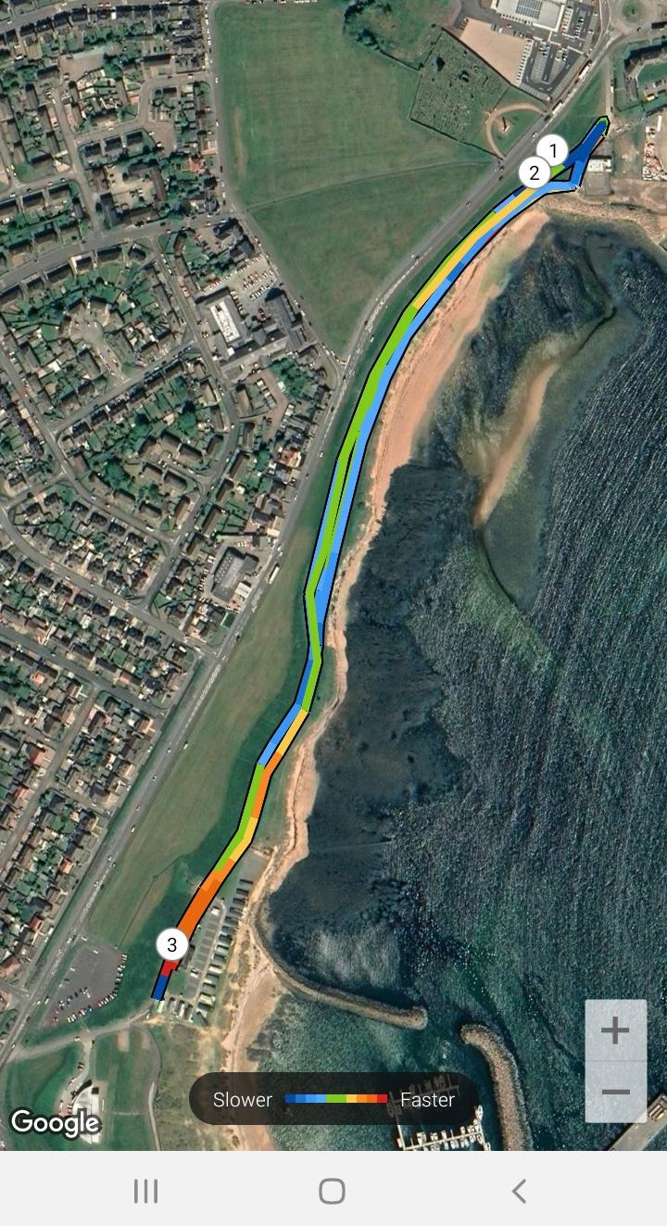

***Junior Mile* – This run starts and finishes at roughly the same point on the tarmac path ±150m from the entrance to the Peterhead Marina Bay caravan park. The mile course follows the path heading north towards the centre of town for ±250m, then taking a left at the path junction onto the upper path. At the end of the upper path, turn right and down on to the lower path, continuing along to finish line at the black bollards, close to where the run started.**

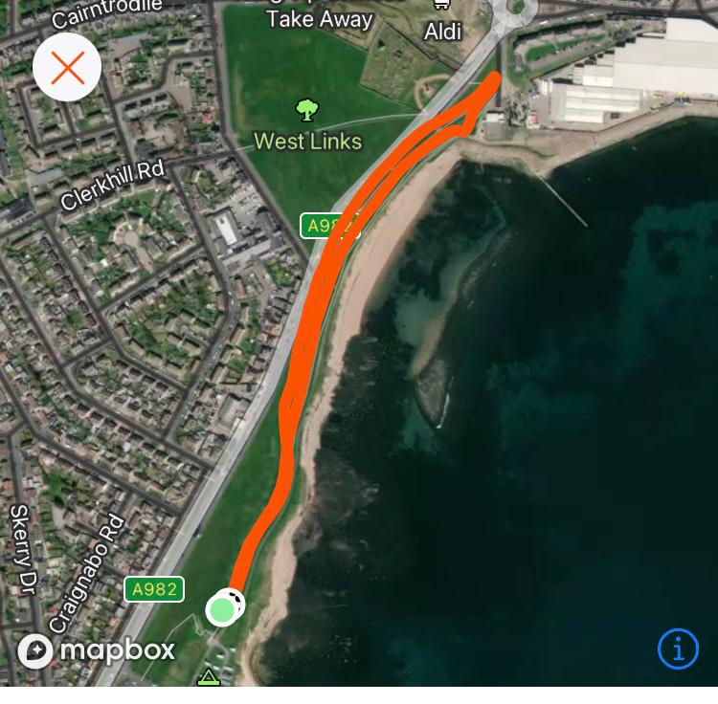

**Event Times**

***Junior Mile –* The junior races will be split into two categories, one for the under 12’s and a second race for athletes aged 12 – 15. The U12’s race will commence at 10:00amwith the 2nd race for U16’s starting at 10.30am.**

***3K* – Due to start at 11:00am.**

**Additional Notes**

* **For both events, marshals and a first aider will be present.**
* **Athletes are advised to stick to the left-hand side of the pathways as much as possible whilst running the route.**
* **As the Lido area is used by members of the public, athletes are asked to please be mindful of, and courteous to, any pedestrians, cyclists or dog walkers that may be using these paths whilst running the route.**

**For any further questions or queries about the event series, please contact;**

[**pacevents-phdathleticsclub@outlook.com**](mailto:pacevents-phdathleticsclub@outlook.com)

**Alternatively you can always contact our club Chair or Secretary;**

**Ewan McGee –** [**chair-phdathleticsclub@outlook.com**](mailto:chair-phdathleticsclub@outlook.com)

**Mary Milne –** [**secretary-phdathleticsclub@outlook.com**](mailto:secretary-phdathleticsclub@outlook.com)

**Peterhead Athletics Club**

**Scottish Registered Charity No. SC051272**

